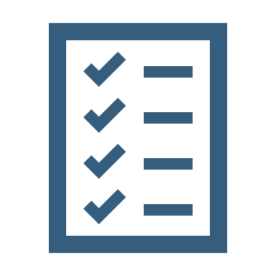  Library Pathway  Self-Assessment  Year 1 UG | Score 2 I fully understand this and could teach it to a friend  Score 1 I have some understanding but some support would be helpful  Score 0 I am not confident with this at all  Use the scored statements above to rate your confidence against the full list of competencies below  Can you do this? 2 1 0 Try this  I can find the library (physical + online) Go  I can use library search Go  I can use my library card and my account Go  I know where to find help using the library Go  I can find and use my reading lists Go  I can find and explore my subject guide Go  I can use a simple search strategy Go  I can identify keywords for search Go  I recognise different types of sources Go  I understand what to use and when Go  I understand the need to be critical Go  I can distinguish between high- and low-quality sources Go  I understand the value of library sources Go  I can interpret the brief Go  I can identify the parameters of my research Go  I can identify my information need Go  I can choose resources to help meet my information need Go  I can review the sources I have used to select the most useful Go  I can gather evidence from my sources for my written argument Go  I understand why referencing is a part of academic writing Go  I know where to find guidance on Harvard referencing Go  Identify some competencies to develop. Focus on those that you scored yourself a zero for initially.

