Cudos – a user guide for students

At FX Plus, we now use Cudos, an online system which makes it easy to view and approve your NMH (Non-Medical Helper) support.

Accessing the system
Click the link to go to the Cudos log-in page. (You might want to add this to your favourites/bookmarks.)
Log in using your university email and password.

First log in
The first time you log in, the system will ask you to read our Privacy Statement and our Terms of Provision. You will need to tick a box on screen to confirm you have read and understood these.
If you want to look at these again, you can find them on the Study Hub:
- Privacy Statement (how we use and store your data)
- Terms of Provision (how we work with you).

Your home page
Your home page will look like this:
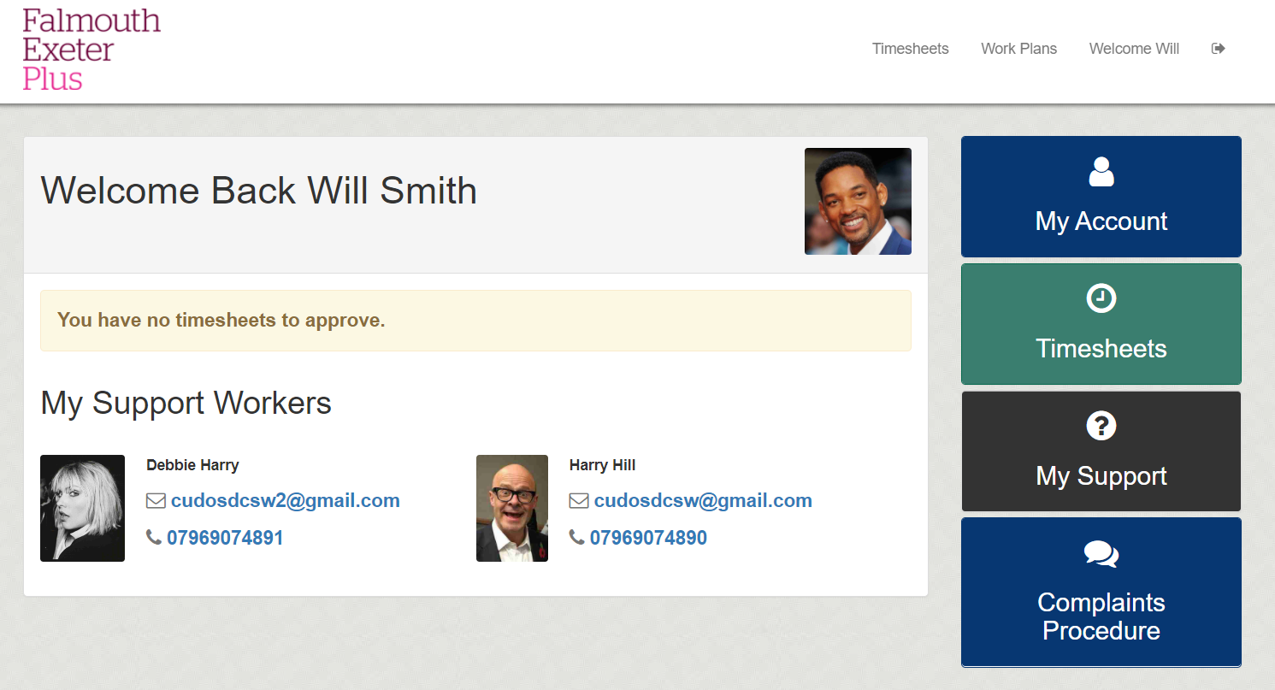
You will see details of who is providing your support along with a notification telling you if you have any timesheets which are awaiting your approval.
Clicking ‘My Account’ will display your basic contact information and give you the option to upload a profile photo if you wish by clicking the ‘Change’ link below the image.
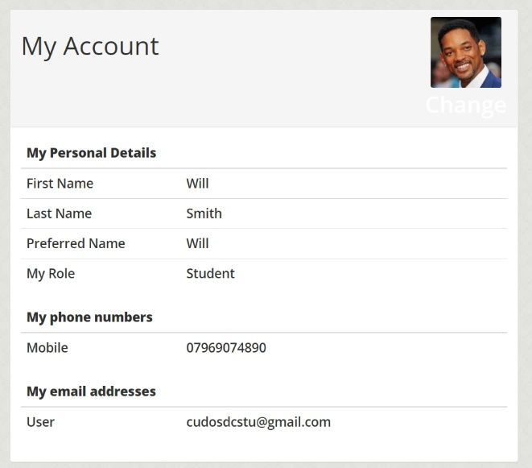
If any of the details here are wrong, you should email us at accessibility@fxplus.ac.uk so we can change them.

Timesheets
After each session you have with your support worker, they will submit a timesheet with details of the session. You should then approve the timesheet. There are two ways to do this.

Approving your timesheet by email
When your support worker submits a timesheet, you will receive an email notification like this one:
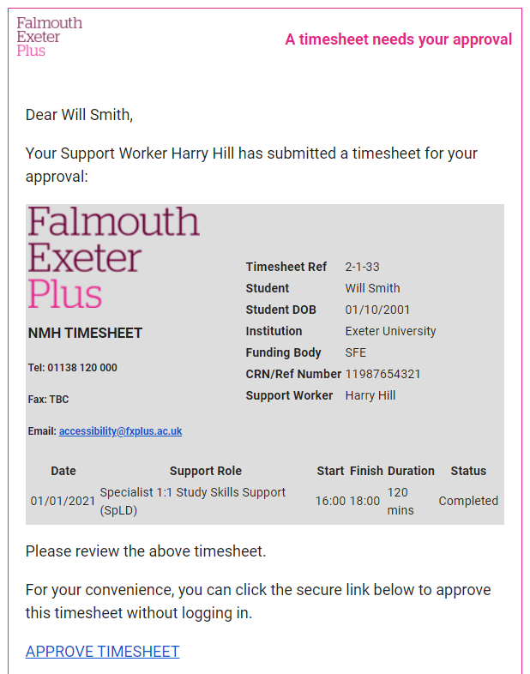
Review the timesheet and check that the dates and times listed are correct. Click the blue link to ‘Approve Timesheet’.
That’s it! You’ve approved this session and your support worker will be paid. You don’t need to do anything else.

Approving your timesheet from your account
Alternatively, you can approve timesheets by logging into your
account and clicking the notification as pictured below.
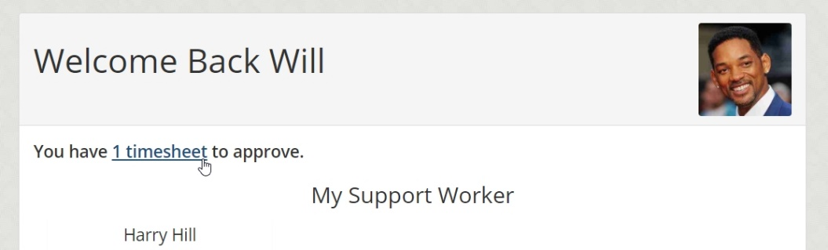
You will then see a list of timesheets which have been submitted by your support worker and are awaiting your approval. Click ‘View Sessions’ to see the contents of the timesheet.
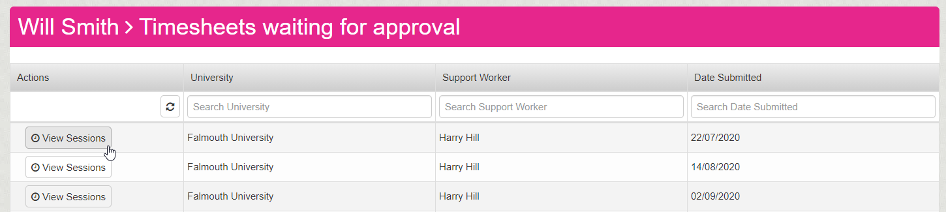
Review the timesheet to check that the dates and times listed are correct. Click the green link shown above to ‘Approve Timesheet’.
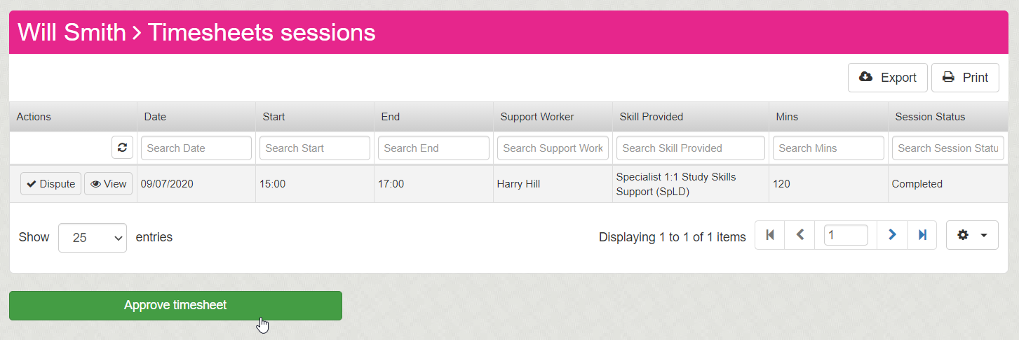
You’re done! You’ve approved this session and your support worker will be paid. You don’t need to do anything else.

What if the timesheet details are wrong?
If any of the details on your timesheet don’t look right, you should log into your account and click the option to ‘Dispute’ the timesheet.
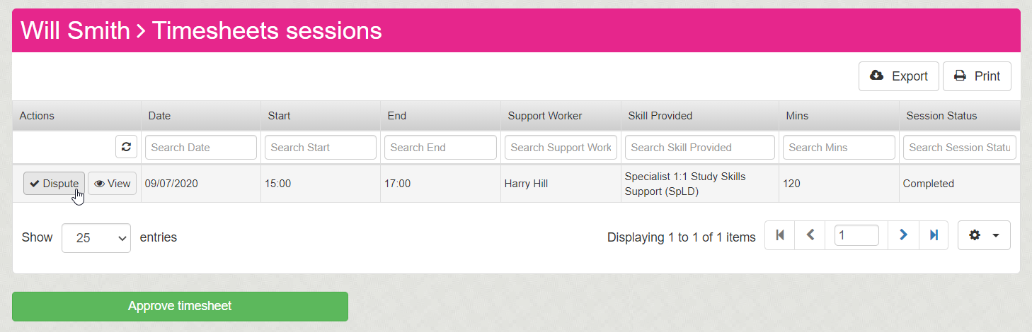
Enter as much information as possible to the box shown above and click ‘Create dispute’. This will notify a member of the Accessibility Team who will then investigate.
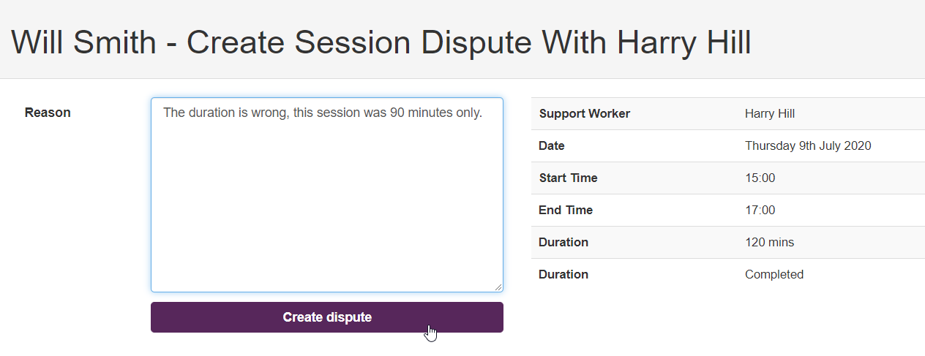

Viewing your session logs
If you want to look back at a previous session, you can click ‘Session logs’ under ‘My Support Workers’, as seen below:
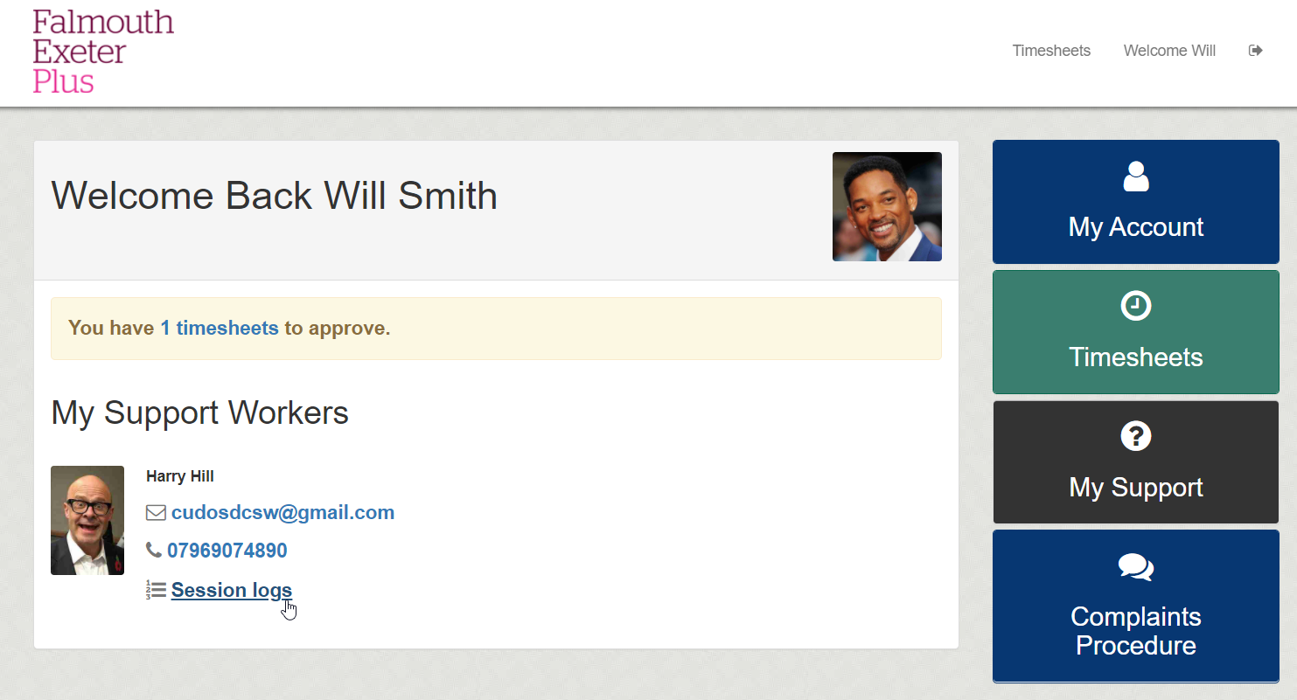
You will then see details such as the date, time, location and what was covered in the session.
