Alternative formats on the Learning Space

Using the Blackboard Ally tool

To monitor digital accessibility
Next to documents in Learning Space modules, you will see the Ally coloured speedometer showing how accessible the document is from green (accessible) to amber to red (inaccessible).
Note: If you are having difficulty accessing documents, use this Digital Accessibility Requests and Complaints Form.
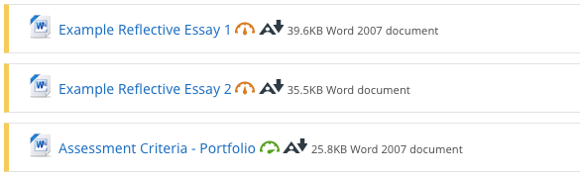

To download alternative formats
You will also see an A with a downward arrow. Clicking this allows you to download the document in other formats, such as html, ePub or audio file. Try these out to see how useful they are.
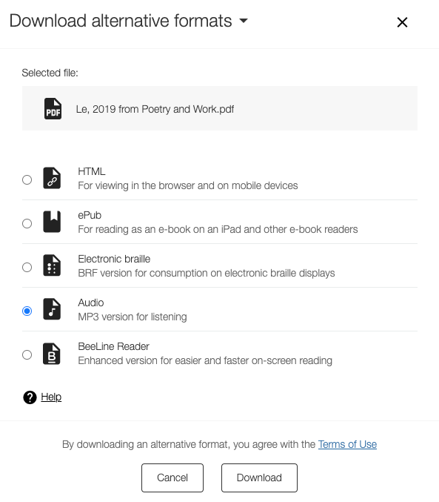

Getting more out of pdfs
With pdfs, it is best to download them rather than trying to access them in the browser, as you will get more functionality.
Most people use one of two free pdf readers: Adobe Reader or Preview (on Macs). The instructions below will not always work, so you might want to try Natural Reader Online instead.

Using Adobe Reader (PC or Mac)
- Control (or Command on a Mac) and + (or -) will make text larger (or smaller). You can also use the View/Zoom menu.
- Go to View/Zoom/Reflow to fit larger text to the width of the page.
- Switch on Read Out Loud by going to View/Read Out Loud then activating. Then tell it to read the page.
- Edit/Accessibility/Setup Assistant allows you to set up options for screen readers and magnifiers including colour, highlighting, reading order, amount to read in one go, zoom.
- Go to Edit/Find to look for specific words or phrases.

Using Preview (Mac only)
- Command and + (or -) will make text larger (or smaller).
- Go to Edit/Speech to start or stop speaking out loud.
- Go to Edit/Find to look for specific words or phrases.

Using Natural Reader Online
- Go to https://www.naturalreaders.com/online/
- You can paste text into the window to read out loud if it is short.
- To upload pdfs, you’ll be prompted to sign up for a free account.
- The free account offers unlimited minutes of basic voices (UK Daniel is good) and 20 minutes a day of the premium voices.
- Basic controls (see screenshot below):
  - Upload the pdf or other document.
  - Play (and pause).
  - Change voices.
  - Change speed.
  - and 7. Other settings.
  - Toggle dyslexia font on or off.
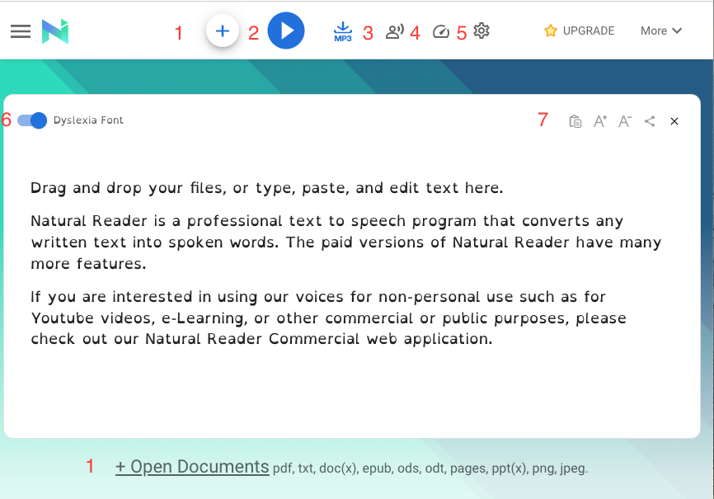

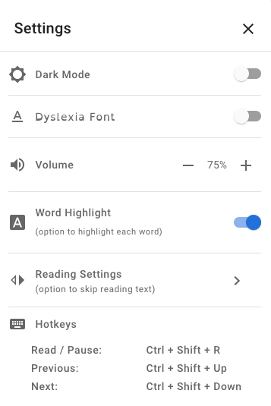
- When you’ve uploaded your pdf or other document, click on its name and it will open in Natural Reader Online where you can hear it read out loud with highlighting.

