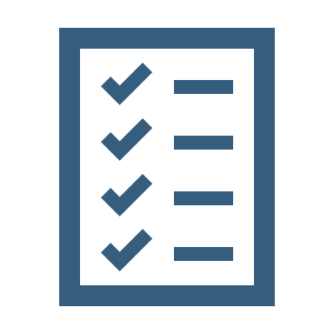  Self-Assessment  AdvancedLibrary Pathway | Score 2 I fully understand this and could teach it to a friend  Score 1 I have some understanding, but some support would be helpful  Score 0 I am not confident with this at all  Use the scores above to rate your confidence for each statement  Can you do this? 0 1 2 Try this  I can define the scope of the research question Go  I can find and use my reading lists Go  I can find and explore Library subject guides Go  I can create and apply sophisticated strategies for finding information Go  I can search effectively across a wide range of information sources Go  I can apply relevant criteria to filter large quantities of information Go  I can critically evaluate information Go  I can use sources of current information for keeping up-to date Go  I can refocus my search according to my developing ideas Go  I can demonstrate accurate and appropriate referencing Go  Add up your scores out of 20  If you scored less than 10 then we recommend revisiting some of the self-help resources. Identify some areas for development. Focus on those that you scored yourself a zero for initially.  If you need help, please contact your librarian

